HOST MERN PROJECT TO AWS

1. Sign in to aws by email & password
2. Start by making EC2 instance
3. Click on EC2 First, select Ubuntu 18.04 LTS, for instance, and select the free tier.
4. Second, create the following entries in the Security Group settings of the instance selected above.

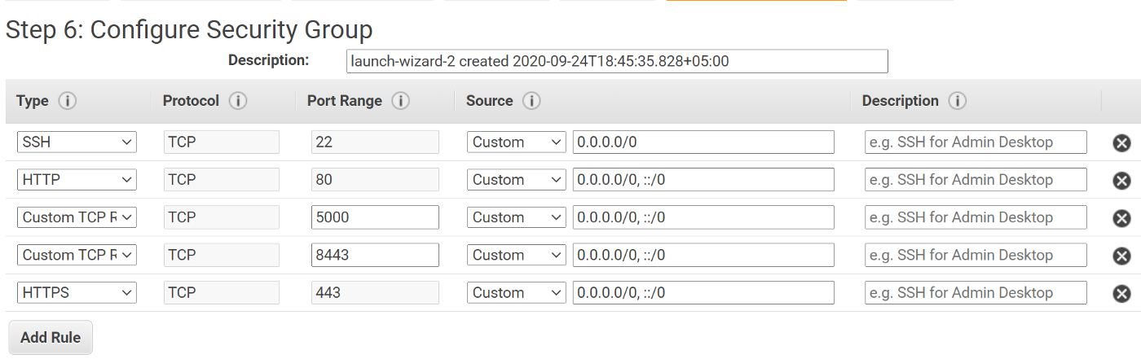

1. Create a security key pair and download the .pem file as shown 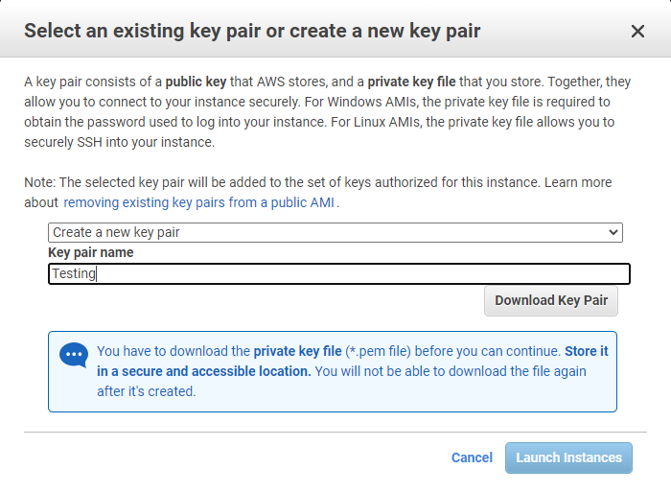
2. Connect to the instance using the SSH as suggested by AWS on Mac, or if you are a Windows user, then follow the AWS guide on how to connect to the instance using Putty, as described in this link.  
   <https://docs.aws.amazon.com/AWSEC2/latest/UserGuide/putty.html?icmpid=docs_ec2_console>
3. Once connected, you need to set up the following list of things on the instance for your application to run.
4. Node.js & npm
5. Code setup (git or FTP)
6. Web server (nginx)
7. Database (Mongodb)
8. Process manager ([PM2](https://pm2.keymetrics.io/))

Note :

Connect server to your remote system (Window Users):

* Install Putty on your system.
* Convert the .pem to putty .ppk file using Puttygen and save its private key.
* Open Putty
* Paste Public IP of your server (on Aws) to Host Name( Ip address in Putty)
* Open connection section in putty
* In Data section, add username ubuntu
* In Auth section, Browse the .ppk file saved by you.
* Click on Open , It will open your server on your remote system. Also, you can store this session with any name , so every time you don't need to fill all credentials.